[Slide Sea 1]

Cargo Securing at Sea Transport
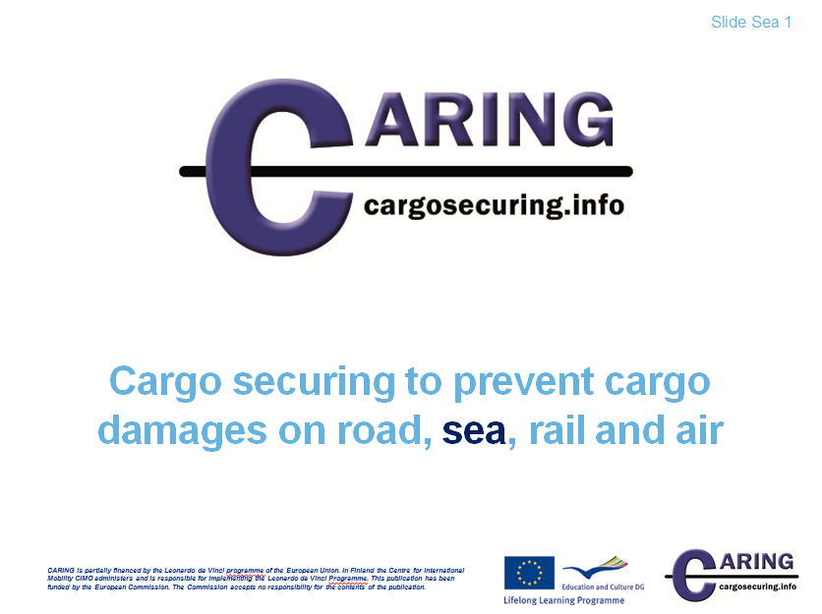

[Slide Sea 2]

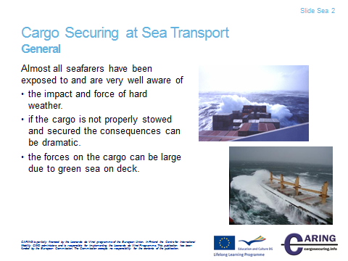

General
Apart from some “sweet water sailors” almost all seafarers have been exposed to hard weather.
If the cargo is not properly stowed and secured when the ship starts to roll and pitch in hard weather it is obvious that the consequences can be dramatic.
In severe weather conditions, if necessary, the speed should be reduced and the course be altered. Such precautions may decrease the level of stress, both to cargo and the ship’s structure, by avoiding large movements and heavy exposure to green sea on deck.

Notes
__________________________________________________________________________________
__________________________________________________________________________________
__________________________________________________________________________________
__________________________________________________________________________________
__________________________________________________________________________________
__________________________________________________________________________________
__________________________________________________________________________________

[Slide Sea 3]

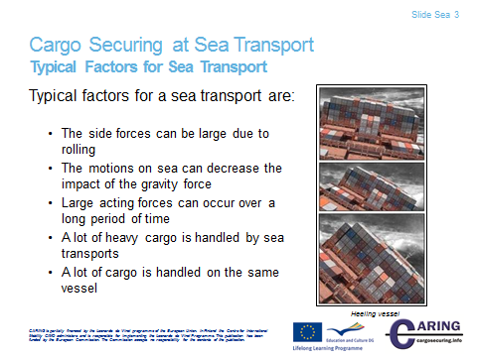

Typical factors for Sea Transport
Typical factors for a sea transport are:
- The side forces can be large due to rolling e.g. everyone who has been out on a ship in heavy weather has an experience of the difficulties of standing still when the ship starts to roll.
- The motions on sea can decrease the impact of the gravity force.
- Large acting forces can occur over a long period of time e.g. the time for a ship voyage from Europe to Eastern Asia is over two weeks.
- A lot of heavy cargo is handled by sea transports e.g. steel coils, machineries etc. if they come loose the consequences can be fatal.
- A lot of cargo is handled on the same vessel e.g. a large container vessel has a capacity of over 14 000 TEU (Twenty foot Equivalent Unit) with a cargo value of over ½ billon US$.

Even if the risk of cargo shifting is well known amongst seafarers, major accidents repeatedly occur on the oceans and the fact is that cargo shifting and operational faults represent the highest portion of the total loss of RoRo-vessels.
As can be seen from statistics from a classification society up to 43% of total losses of RoRo-vessels during a certain period of time were due to shift of cargo and operational faults.
The accidents might in many cases be explained by both unawareness and lack of education amongst crewmembers but may also be explained by factors that could not have been foreseen or predicted by the seafarers.

Notes
__________________________________________________________________________________
__________________________________________________________________________________
__________________________________________________________________________________
__________________________________________________________________________________
__________________________________________________________________________________
__________________________________________________________________________________
__________________________________________________________________________________
__________________________________________________________________________________
__________________________________________________________________________________
__________________________________________________________________________________
__________________________________________________________________________________

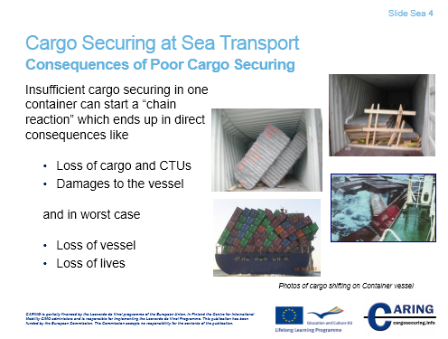
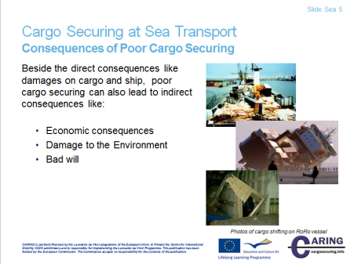
[Slide Sea 4 & 5]

Consequences of poor cargo securing
The consequences of insufficient cargo securing can be divided into two main groups, direct and indirect consequences:

Direct consequences
- Loss of cargo and CTU:s
- Damages to the vessel
or in worst case
- Loss of vessel
- Loss of lives

The worst consequence of badly loaded and secured cargo is when persons are getting injured or killed. When handling CTU:s with curtain sides such as swap bodies or trailers, the personnel working in terminals and ports are exposed to great danger due to the risk of cargo breaking out. Similarly, railway personnel, sailors, truck drivers and road-users are exposed to danger as insufficiently lashed and secured cargo at any time may break out of a CTU. Also the persons unloading the cargo are exposed to danger if the cargo has shifted in the CTU during the transport.

The risks are of course extra high for both persons and environment when cargoes classified as "dangerous" are exposed to cargo shifting.

If the cargo starts to shift during a sea voyage in bad weather conditions it can be very dangerous for the crew on board to try to take care of the shifted cargo or CTU. The master has to manoeuvre the vessel in a way to stabilise the situation and then fix the shifted cargo or CTU at port.

Indirect consequences
- Economic consequences
- Damage to the Environment
- Bad will

Cargo damage during transportation costs large amounts annually. During only one autumn and winter season on the North Sea, cargo may be damaged to the value of more than 20 million dollars.

Injuries to persons and damages to the environment cause great cost to the society even if everything can't be compensated. The damages cannot always be estimated in money. Production is delayed, replacements must be manufactured and time schedules have to be changed.

Costs and delays arise when ships, vehicles, railway wagons and other CTU:s are damaged or destroyed due to cargo shifting.

Costs also arise when shifted cargo must be reloaded or when an entire ship deck must be emptied after a total cargo shift where different cargoes have been mixed.

Many industries have long transport distances to their markets. In the long run, the suppliers loose goodwill if the cargo is repeatedly damaged before reaching the customer.

Notes
__________________________________________________________________________________
__________________________________________________________________________________
__________________________________________________________________________________
__________________________________________________________________________________
__________________________________________________________________________________
__________________________________________________________________________________

[Slide Sea 6]

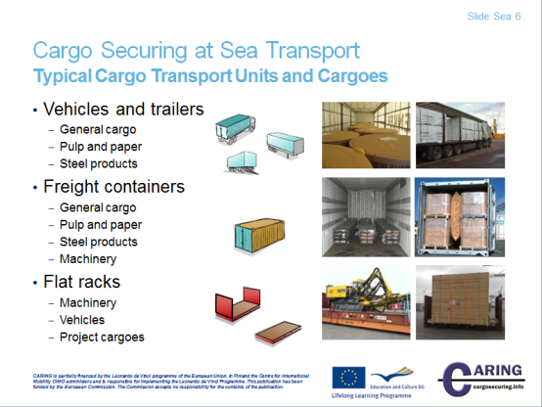

Typical Cargo Transport Units and Cargoes
Vehicles, Semi-trailer and Trailer
Mainly for road transport but could also be in combined transport on railway and short sea transports (non-ocean going). The superstructure of the vehicles has a great impact on the required securing arrangement.

Container and Flat Racks
Mainly for sea transport but is common also in road and railway transports. The walls of a standard ISO freight container are built to manage the forces from cargo in motion.

Typical Cargo
- General cargo: Chemicals, electronics, foodstuff etc.
- Pulp and paper: paper reel, sheeted paper pallets, pulp bales
- Steel products: steel bars, slabs, coils, pipes etc.
- Machinery: Turning machines, grinding machines etc.
- Vehicles: Cars, trucks, Construction equipment etc.
- Project cargo: Cranes, Heavy forklifts, wind mills, rock drills etc.

Notes
__________________________________________________________________________________
__________________________________________________________________________________
__________________________________________________________________________________
__________________________________________________________________________________

[Slide Sea 7 & 8]

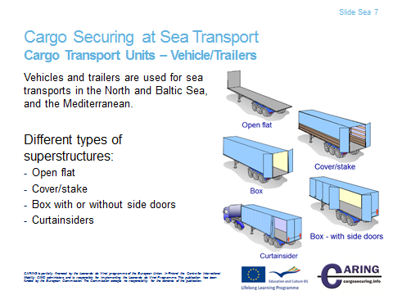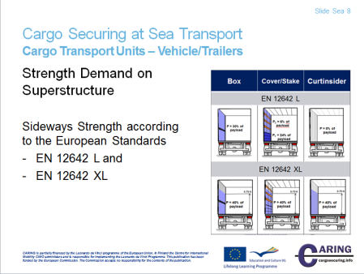

Cargo Transport Units – Vehicle/Trailers
Different types of superstructure are more or less suitable for cargo securing for a sea transport.
The headboard is normally strong enough to be used for blocking. In some countries there are strength demands for the headboard and in certain countries it is required that the vehicle driver has a certificate showing the strength of the headboard. The strength requirements of superstructure and lashing points can be found in the standard EN 283 (swap-body), EN 12642 L (old level of requirements for vehicle superstructure) or XL (latest version of requirement for vehicle superstructures) and EN 12640 or XL (lashing points).

Open flat
If the headboard is strong enough it can be used for blocking. The cargo securing arrangement has then to be complemented by blocking by e.g. wooden battens, bars and braces or with lashing.

Cover/stake
The headboard requirements are the same for a cover/stake superstructure as for an open flat. The side of the superstructure can only be used for cargo blocking if it’s designed to carry the load, see standard EN 12642 L or XL (or EN 283). Cargo layers blocked by the superstructure over the side board height have a weight limit due to the design of the superstructure.

Box (with or without side doors)
The headboard requirements are the same for a box superstructure as for an open flat. The side walls can normally be used for cargo blocking if they are designed to withstand the load see standard EN 12642 L or XL (or EN 283).

Curtainsiders
Curtainsiders are common because they are easy to load/unload from the side and top. The superstructure of Curtainsiders has less weight compared to box and cover/stake superstructures which leads to higher payload and less construction cost.
The disadvantage with Curtainsiders is that the sides are normally not designed to withstand any load. They can therefore not be used for cargo blocking unless they are purposely built.
In the extended version of the standard EN 12642 the level XL has the same requirements on the superstructure strength for box, cover/stake and Curtainsiders types.

Notes
__________________________________________________________________________________
__________________________________________________________________________________
__________________________________________________________________________________
__________________________________________________________________________________
__________________________________________________________________________________
__________________________________________________________________________________
__________________________________________________________________________________
__________________________________________________________________________________
__________________________________________________________________________________
__________________________________________________________________________________
__________________________________________________________________________________

[Slide Sea 9 & 10]

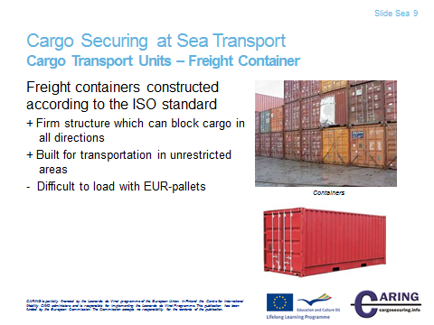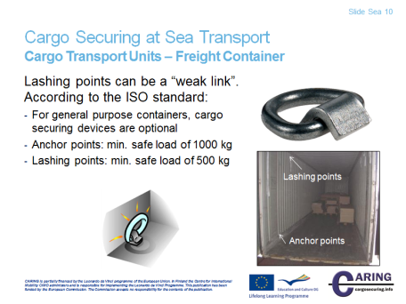

Cargo Transport Units – Freight Container
If the container is designed according to the ISO-standard 1496-1 the cargo can be evenly blocked against the sides and end walls of the container.
A disadvantage with a freight container is that the size of a EUR-pallet 1200 x 800 mm doesn’t fit well to the internal dimensions of the ISO container e.g. 20 ft container with inner dimension 5867 × 2330 mm. This fact leads to loading patterns with a lot of void spaces to take care of when securing the cargo.

When lashings are used to secure the cargo inside a container one has to consider that requirements on the lashing points in an ISO-container are comparatively low and the securing points become the “weak link” in the securing arrangement.

According to the ISO standard the lashing points can be a “weak link”;
- For general purpose containers, cargo securing devices are optional
- Anchor points shall be designed and installed to provide a minimum safe load of 1000 kg, applied in any direction
- Lashing points shall be designed and installed to provide a minimum safe load of 500 kg, applied in any direction

Notes
__________________________________________________________________________________
__________________________________________________________________________________
__________________________________________________________________________________
__________________________________________________________________________________
__________________________________________________________________________________

[Slide Sea 11]

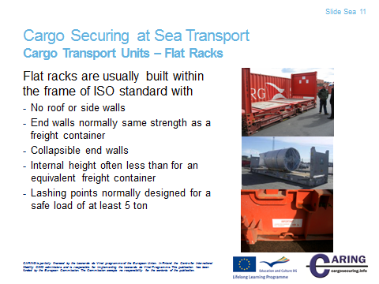

Cargo Transport Units – Flat Racks
A flat rack (Container platform) is a cargo transport unit without roof and side walls. The flat rack can be provided with or without end walls. If a rack with end walls should be handled in a normal way in the container transport system it requires the end walls to withstand the same forces as for a general freight container.

The flat rack is usually manufactured within the frame of the ISO-standard and mainly with a length of 20 or 40 ft.

The flat rack “tare” weight is the same or somewhat higher than the corresponding tare for a general freight container. A normal 20 ft. platform with end walls has MGW (Maximum Gross Weight) 24 000 kg and a tare weight of approx. 2 500 kg, consequently a payload of approx. 21 500 kg. A normal 40 ft. platform with end walls has MGW 30 480 kg and a tare weight of approx. 5 000 kg, consequently a payload of approx. 25 500 kg.

A flat rack with end walls gives better protection to the cargo than a platform without end walls, at the same time the possibility to secure the cargo increases. Flat racks with end walls can be stacked in terminals and on board ships without any stress on the cargo.
A flat rack with end walls uses less volume when transported empty and therefore some platforms are equipped with collapsible end walls.

The internal height of a platform-based container with MGW according to the ISO-standard is often less than the height mentioned in the standard for a freight container. With the internal height means the distance between the floor and the upper edge of the upper corner fittings. You should not use the total internal height since a container or flat rack stacked on top of the platform-based container can sag and destroy the cargo.

The height of the platform floor has to be approx. 600 mm to carry the loads from the cargo, which means that the internal height is significantly lower than for a general container. In some cases the internal length can also be considerably shorter than for a general container as the end walls have to be made strong to withstand the designing forces.

Notes
__________________________________________________________________________________
__________________________________________________________________________________
__________________________________________________________________________________
__________________________________________________________________________________
__________________________________________________________________________________

[Slide Sea 12]

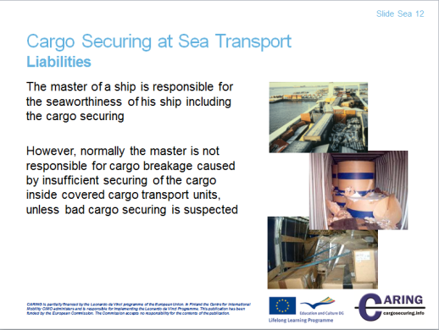

Liabilities
The different parties in the transport chain are normally insured for cargo damages and the responsibility for damages during an international road transport is for example regulated in the “CMR-convention” ( CMR = Convention relative au contrat de transport international de Marchandises par Route ).

On the other hand if “third parties”, e.g. persons or environment, have been injured or damaged public law has to be taken into consideration to find out who is responsible for the cargo securing. In this case it can be very complicated to sort out the different party’s responsibilities, which often require juridical expertise.
The legislation in different countries varies a lot and therefore is the description in the section below only a general discussion over the responsibility for the different parties in the transport chain. To get a full picture of the liabilities you have to get information about the national laws in actual countries.

Sea transport
The master of a ship is responsible for the seaworthiness of his ship including the cargo securing. According to some countries’ maritime laws, the master is, however, not responsible for cargo breakage caused by insufficient cargo securing inside covered cargo transport units, unless bad cargo securing is suspected. E.g. cargo partly protrudes from the CTU or bad cargo distribution in the CTU. The responsibility lies with the contracting part to the ship-owner, which in many cases is the forwarding agent.

Notes

__________________________________________________________________________________
__________________________________________________________________________________
__________________________________________________________________________________
__________________________________________________________________________________
__________________________________________________________________________________
__________________________________________________________________________________
__________________________________________________________________________________
__________________________________________________________________________________

[Slide Sea 13 & 14]

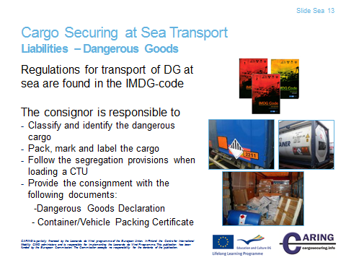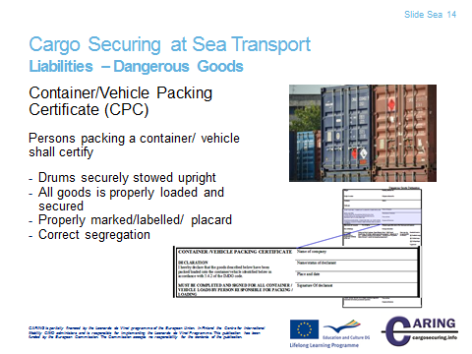

Liabilities – Dangerous Goods
The responsibility of the consignor (shipper):
- Classify and identify dangerous cargo
- Pack the cargo in approved packagings
- Mark and label the cargo
- Follow the segregation provisions when loading a CTU
- Provide the consignment with the following documents:
- Dangerous Goods Declaration
- Container/Vehicle Packing Certificate
- Provide appropriate training to the personnel involved

The responsibility of the shipping company (transporter):
- Check that the dangerous goods is approved for sea transport
- Check the Dangerous Goods Declaration.
- Check if the Container/Vehicle Packing Certificate is signed by the responsible loader (if applicable)
- Control the marking and placarding of the CTUs
- Follow the stowage categories
- Follow the segregation provisions when loading the CTUs
- Provide appropriate training to the personnel involved

Persons packing a container/vehicle to certify:
- Container/vehicle was clean/dry/fit to receive goods
- Correct segregation
- External inspection shows no damage
- Drums securely stowed upright
- All goods is properly loaded and secured to suit the modes of transport for the journey
- Even distribution of bulk loads
- Structurally serviceable
- Properly marked/labelled/placard
- Marked/labelled for CO2 – dry ice as appropriate
- Transport document received for each dangerous goods consignment
Notes
__________________________________________________________________________________
__________________________________________________________________________________
__________________________________________________________________________________
__________________________________________________________________________________
__________________________________________________________________________________
__________________________________________________________________________________
__________________________________________________________________________________
__________________________________________________________________________________

[Slide Sea 15]

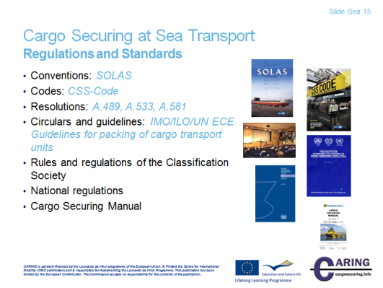

Regulations and standards
Conventions
Of all the international conventions dealing with maritime safety, the most important is the International Convention for the Safety of Life at Sea, better known as SOLAS. This convention covers a wide range of measures designed to improve the safety of shipping.
Contracting governments are those countries that are members of IMO and adopt work and publications from IMO.

A convention published by IMO is law in the country and on board vessels carrying the flag of the Contracting Government, which has adopted the convention.
The SOLAS Convention is also one of the oldest of its kind. The first version was adopted already in 1914 followed by the sinking of Titanic, with the loss of more than 1 500 lives. Since then several versions of SOLAS have been published.
The requirements on cargo securing in SOLAS are merely on a general level. § 6 of regulation 5 in chapter VI contains, however, very specific requirements which are expressed as follows:
“All cargoes, other than solid and liquid bulk cargoes, cargo units and cargo transport units shall be loaded, stowed and secured throughout the voyage in accordance with the Cargo Securing Manual approved by the Administration. In ships with ro-ro spaces, as defined in regulation II-2/3.41, all securing of such cargoes, cargo units and cargo transport units, in accordance with the Cargo Securing Manual, shall be completed before the ship leaves the berth. The Cargo Securing Manual shall be drawn up to a standard at least equivalent to relevant guidelines developed by the Organization”

Codes
A code is a document from IMO stipulating and describing how things shall be properly done in order to avoid jeopardising the safety.
A code may either be part of SOLAS, which thereby become mandatory in the country of the Contracting Governments, or a document that the assembly at IMO recommends being implemented by the Governments.

The CSS Code contains the following 7 chapters:
Chapter 1 - General
Chapter 2 - Principles of Safe Stowage and Securing of Cargoes
Chapter 3 - Standardized Stowage and Securing Systems
Chapter 4 - Semi-Standardized Stowage and Securing
Chapter 5 - Non-Standardized Stowage and Securing
Chapter 6 - Actions Which may be Taken in Heavy Weather
Chapter 7 - Actions Which may be Taken once Cargo has Shifted

Additionally the Code contains the following 13 annexes:
Annex 1 - Safe stowage and securing of containers on deck of ships which are not specially designed and fitted for the purpose of carrying containers
Annex 2 - Safe Stowage and securing of portable tanks
Annex 3 - Safe stowage and securing of portable receptacles
Annex 4 - Safe Stowage and Securing of Wheel-Based (Rolling) Cargoes
Annex 5 - Safe Stowage and Securing of Heavy Cargo Items such as Locomotives, Transformers, etc.
Annex 6 - Safe Stowage and Securing of Coiled Sheet Steel
Annex 7 - Safe Stowage and Securing of Heavy Metal Products
Annex 8 - Safe Stowage and Securing of Anchor Chains
Annex 9 - Safe Stowage and Securing of Metal Scrap in Bulk
Annex 10 - Safe Stowage and Securing of Flexible Intermediate Bulk Containers
Annex 11 - General Guidelines for the Under-Deck Stowage of Logs
Annex 12 - Safe Stowage and Securing of Unit Loads
Annex 13 - Methods to assess the efficiency of securing arrangements for non-standardized cargo

Today the requirements in the CSS Code are incorporated in vessel’s cargo securing manual.

Resolutions
Through the work of IMO sub-committees, important resolutions are produced.
The resolutions may be adopted by the IMO Assembly, the MSC - Maritime Safety Committee or the MEPC - Marine Environment Protection Committee or other sub-committees. Resolutions within the cargo securing field that concerns RoRo vessels are:
A.489: “Safe stowage and securing of cargo units and other entities in ships other than cellular container ships” contains basic definition about how a cargo securing manual shall be designed and constructed.
A. 533: Elements to be taken into account when considering the safe stowage and securing of cargo units and vehicles in ships.
A. 581: Guidelines for securing arrangements for the transport of road vehicles on RoRo ships.

Circulars and guidelines
General information with explanations and guidelines are often distributed as circulars from the IMO sub-committees.
The “IMO/ILO/UN ECE guidelines for packing of cargo transport units (CTU’s)” contains general information on safe stowage and securing of cargo on vehicles and in containers. It can also be said to be relevant for the securing of cargo items inside boxes.
The MSC Circular 745 “Guidelines for the preparation of the Cargo Securing Manual” is important for the development of Cargo Securing Manuals.
Rules and regulations of the Classification Society
The Classification Societies have comprehensive rules and regulations for all parts of a vessel. When it comes to cargo securing the class rules do mainly cover the design of securing arrangements for container vessels.

National regulations
Different flag stats can adopt national regulations in addition to the international rules and regulations.

Cargo Securing Manual
According to SOLAS Convention all Ro-ro vessels shall have an approved Cargo Securing Manual, see section Conventions.

Notes
__________________________________________________________________________________
__________________________________________________________________________________
__________________________________________________________________________________
__________________________________________________________________________________
__________________________________________________________________________________
__________________________________________________________________________________
__________________________________________________________________________________
__________________________________________________________________________________

[Slide Sea 16]

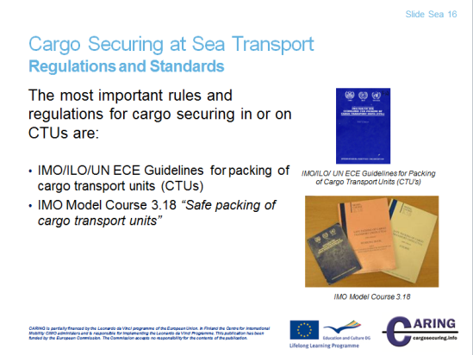

Regulations and standards
The most important rules and regulations for cargo securing of cargo in or on CTUs are:
IMO/ILO/UN ECE Guidelines for packing of cargo transport units (CTUs)
The “IMO/ILO/UN ECE guidelines for packing of cargo transport units (CTU’s)” contains general information on safe stowage and securing of cargo on vehicles and in containers. It can also be said to be relevant for the securing of cargo items inside boxes.
IMO Model Course 3.18 “Safe packing of cargo transport units”
IMO also develops and supplies Model Courses on different topics. Regarding cargo securing, IMO has issued the Model Course 3.18 “Safe packing of cargo transport units”. This model course is a complement to the IMO/ILO/UN ECE Guidelines for packing of cargo transport units.
The model course also contains Quick Lashing Guides with specific instructions on required number of lashings for different lashing types and sea areas.
Notes
__________________________________________________________________________________
__________________________________________________________________________________
__________________________________________________________________________________
__________________________________________________________________________________

[Slide Sea 17]
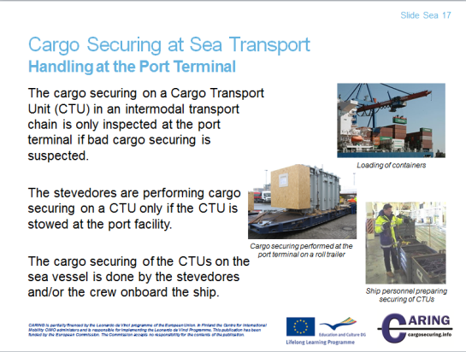

Handling at the Port Terminal
The cargo securing on a Cargo Transport Unit (CTU) in an intermodal transport chain is only inspected at the port terminal if bad cargo securing is suspected.
In the past, before different CTU systems were used by the industry, the cargo was transported loose to the ports where it was stowed and secured in ships by stevedores, who often had experience as sailors and were familiar with forces arising due to ship movements in bad weather.
Nowadays the cargo is not often seen by the stevedores and their work mainly consists of handling, stowing and securing different types of CTU:s in the port and on the ship. These CTU:s may have been loaded at an inland industry where the personnel do not have the same knowledge as the stevedores what happens to the cargo at sea. Due to this the consequences can be devastating.
The stevedores are performing cargo securing on a CTU only if the CTU is stowed at the port facility.
As mentioned above the stevedores normally are not involved in the cargo securing on a CTU in a transport chain. Nevertheless sometimes the cargo are stowed and loaded to CTUs at the port terminal and then of cause the stevedores are involved in the cargo securing. Typical cargo is project cargo like big machinery, construction vehicles, etc. In these cases the cargo can be loaded to cargo transport units designed only for the sea transport e.g. roll trailers, mafi-trailers and cassettes.
The cargo securing of the CTUs on the sea vessel is done by the stevedores and/or the crew onboard the ship.
Every ship carrying packed cargo has a Cargo Securing Manual (CSM) which the stevedores and the ship personnel have to follow when stowing and securing lose cargo and the CTUs on board the sea vessel.
Notes
__________________________________________________________________________________
__________________________________________________________________________________
__________________________________________________________________________________
__________________________________________________________________________________
__________________________________________________________________________________
__________________________________________________________________________________
__________________________________________________________________________________
__________________________________________________________________________________
__________________________________________________________________________________
__________________________________________________________________________________

__________________________________________________________________________________

[Slide Sea 18 & 19]

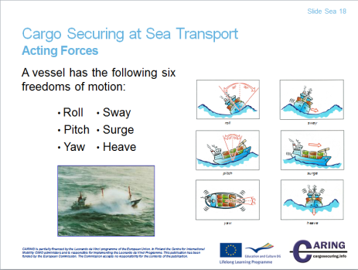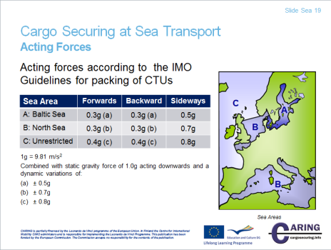

Acting forces
At sea the vessel will move due to waves and swell. The magnitude of the motions is depending on the vessels sea keeping properties and the size of waves and swell. The larger the motions are the larger will the accelerations on board be. These accelerations can be calculated, which will be shown in the following.

A vessel has the following six freedoms of motion, three rotational and three linear:
Roll, Pitch and Yaw as well as Sway, Surge and Heave
Of these the roll, pitch and heave motions are the most well-known and also the motions giving the largest contributions to the accelerations and forces acting on the cargo on board.

Accelerations and mass forces
All objects are unwilling to change the speed or direction in which they are currently traveling. If you are riding a car down the street and suddenly brake, your body will try to continue forward in the original speed but is held back by the seat belt as the car is reducing its speed. During lift off, your body is pushed back into the seat, as the aircraft is accelerating. In these situations you are experiencing the mass force.

A deceleration is a negative acceleration. Accelerations may be expressed as g or m/s2.
The mass force on an object is calculated by multiplying the weight, M, of the object with the acceleration, a, it is experiencing:

F = M ∙ a

Mass forces may be expressed in kN or tons, where 1 ton ≈ 10 Kn.

If the mass is expressed in tons and the acceleration in g in the formula above, the resulting force will be expressed in tons.

If the mass is expressed in tons and the acceleration in m/s2 in the formula above, the resulting force will be expressed in kN. Due to waves, a vessel is constantly making smaller or greater changes in velocity and heading. Mass forces are therefore always acting on the cargo in different directions.

Gravity
Nature has provided us with a gift not often considered by people on earth.
This outmost important gift is called gravity and could be explained as a magnetic force constantly switched on. If someone could switch the gravity off, a complete mess would occur with everything flying around.

By their pure mass, all objects are pulled downwards by gravity with a force of 1.0 g, which could also be expressed as an acceleration of 9.81 m/s2.

Just as for mass forces, the force caused by gravity could be calculated by multiplying the weight, M, of an object with the acceleration of gravity:

F = M ∙ g

If a vessel is heeling, gravity will try to slide the object downwards along the deck.

The forces acting on cargo on board a vessel in waves have two components: a dynamic component from mass forces caused by accelerations and a static component caused by gravity.
The designing stress for cargo securing at sea transport is found in the IMO/ILO/UN ECE guidelines for Packing of Cargo Transport Units.

Sea areas
In Northern Europe the sea can be divided into three sea areas due to magnitude of the forces; A, B and C;

Sea area A: Baltic Sea to a border line Lysekil, Sweden - Skagen, Denmark
Sea area B: The middle North Sea and the English Channel or the Mediterranean.
Sea area C: Unrestricted waters.

The major forces acting on the cargo during a sea transport is when the wind and waves are coming in from the side and the ship starts to roll. In lengthways direction acting forces can be significant when the ship pitches but the magnitude is less than a heavy break for a road transport.

Sea Area Forwards Backwards Sideways
A: Baltic Sea 0.3g (a) 0.3g (a) 0.5g
B: North Sea 0.3g (b) 0.3g (b) 0.7g
C: Unrestricted 0.4g (c) 0.4g (c) 0.8g
1g = 9.81 m/s2

Combined with static gravity force of 1.0g acting downwards and a dynamic variation of:
± 0.5g
± 0.7g
± 0.8g

Notes
__________________________________________________________________________________
__________________________________________________________________________________
__________________________________________________________________________________
__________________________________________________________________________________
__________________________________________________________________________________
__________________________________________________________________________________

[Slide Sea 20]

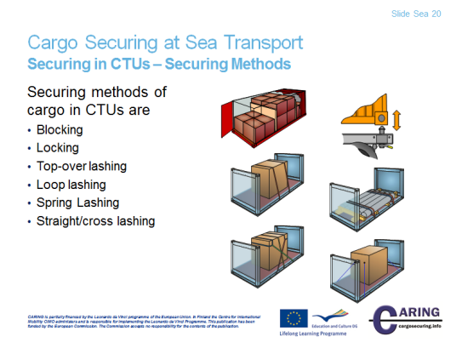

Securing in CTUs – Securing methods
The picture shows different securing methods. The basic method is blocking with or without any securing devices. When the blocking is not enough to prevent the cargo from sliding and tipping the next step is either to complement the blocking with lashing or to secure with lashings only.

Locking
Locking of freight containers to the vehicle or seagoing vessel by twist-locks is a typical way of locking.

Blocking
Blocking against parts of the vehicle signifies that the load is placed in close contact with the headboard or the sideboards. If the load consists of several cargo units they must be packed together as close as possible. Void spaces can occur, due to the shape of the goods and these should be filled out with pallets, dunnage bags etc.
Blocking is first of all a method to prevent cargo from sliding, but if the blocking reaches up to or above the cargo’s centre of gravity it also prevents tipping. Blocking should be used as far as possible.

Top-over lashing
In the standard EN 12195-1 top-over lashing is mentioned as friction lashing. The top-over lashing is placed over the cargo and the purpose is to raise the pressure between the cargo and the platform in order to increase the force of friction. This is a good cargo securing method, but it has an important limitation. The lashing is most efficient if the angle between the loading platform and the lashing is 90°. If the angle diminishes the lashing loses effect. The values in the Quick Lashing Guide are valid for angles between 75-90°. At angles between 30-75° the number of lashing must be doubled. If the angle is under 30° another lashing method should be chosen.
The positioning of the lashing is critical too, primarily for the possibility to prevent tipping forwards/backwards. When a lashing is used it must be placed over the centre of the load.

Loop lashing
A pair of loop-lashings prevents the cargo from sliding and tipping sideways. Minimum one pair of loop lashings per section should be used. When long cargo sections are secured with loop lashings at least two pair of loop lashing should be used to prevent the cargo from twisting.

Spring lashing
A spring lashing is mainly used to prevent cargo from sliding and tipping in the forward or backward direction and can solve many loading problems, in particular when cargo is loaded in a second non- blocked layer. Often the load in the upper layer must be placed away from the headboard in order to not exceed the limits of axle pressure. A spring lashing is then a good solution.

A spring lashing can be made in various manners, but common is that the angle between the lashing and the platform bed should be as low as possible. A spring lashing rapidly loses its effect when the angle is greater. The tables in the Quick Lashing Guides are valid for an angle of maximum 45°.

Straight lashing (cross lashing)
In the standard EN 12195-1 straight lashing is mentioned under the section direct lashing as slope or diagonal lashing. This type of lashing is used primarily on larger machinery and cargo where you can attach the lashing directly to the cargo. A straight lashing prevents both sliding and tipping. Depending on the angle between the securing point on the cargo and the securing point on the platform, the effect to prevent tipping is different to that of sliding.

Notes
__________________________________________________________________________________
__________________________________________________________________________________
__________________________________________________________________________________
__________________________________________________________________________________
__________________________________________________________________________________
__________________________________________________________________________________
__________________________________________________________________________________
__________________________________________________________________________________

[Slide Sea 21]

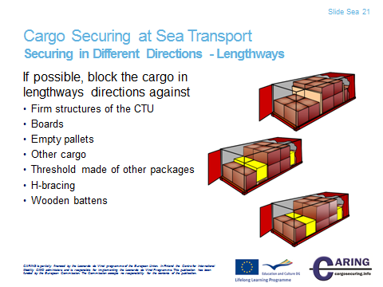

Securing in Different Directions – Lengthways
The best way to prevent forward movements is to block all packages with a tight stow from the headboard and backwards. If the packages are at least bottom blocked they are prevented from sliding and if the blocking reaches up to the centre of gravity they are also prevented from tipping.

The blocking can be arranged by
- Firm structures of the CTU e.g. support from headboard, drop sides, container end walls etc. Note some countries require that the strength of superstructure is guaranteed by a certificate from the manufacturer
- Boards
- Empty pallets
- Other cargo
- Threshold made of other packages
- H-bracing
- Wooden battens

Notes
__________________________________________________________________________________
__________________________________________________________________________________
__________________________________________________________________________________
__________________________________________________________________________________
__________________________________________________________________________________
__________________________________________________________________________________

[Slide Sea 22]

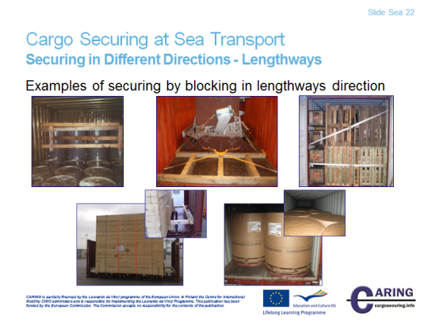

Securing in Different Directions - Lengthways
Examples of securing by blocking in lengthways direction
- Blocking by bars
- Blocking by H-braces
- Blocking by empty pallets
- Blocking by wooden battens (H-brace)
- Blocking by the cargo itself

Notes
__________________________________________________________________________________
__________________________________________________________________________________
__________________________________________________________________________________
__________________________________________________________________________________
__________________________________________________________________________________
__________________________________________________________________________________
__________________________________________________________________________________
__________________________________________________________________________________

[Slide Sea 23]

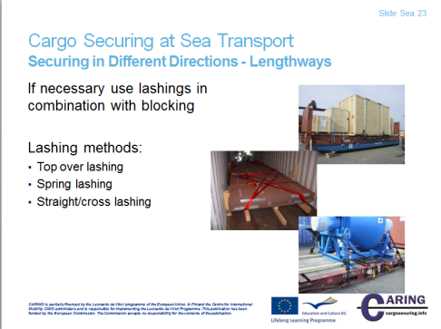

Securing in Different Directions - Lengthways
If blocking cannot be sufficiently arranged, the cargo can be secured by complementary lashings or by lashings only.

Top-over lashings
The top-over lashings run from side to side over the load. The top-over lashing is most efficient if the angle between the loading platform and the upright part of the lashing is close to 90°. If this angle diminishes the lashing loses effect.
In the Quick Lashing Guides, the number of lashings is calculated for an angle between 90° and 75°. At angles between 75° and 30° the number of lashings must be doubled. If the angle is less than 30° the lashing has almost no effect and another securing method must be used.
To prevent longitudinal tipping, the lashings should be placed symmetrically.

Spring lashing
A spring lashing is used to block the load in the forward or backward direction and can solve many loading problems. In the Quick Lashing Guides, the number of lashings is calculated for an angle between the platform and spring lashing of maximum 45°.

Straight lashing – Cross lashing
This type of lashing is used primarily on larger machineries and cargoes where the lashing can be attached directly to the cargo. This lashing can prevent both sliding and tipping. Depending on the angle between the attachment point on the cargo and the attachment point on the floor, the effect to prevent tipping is different to that of sliding. If the lashings are put crossways (cross lashing) it is of utmost importance that the cross is located over the centre of gravity of the cargo - otherwise the lashings may help the cargo to tip over. In the Quick Lashing Guides, the number of lashings is calculated for horizontal and vertical angles between 30° and 60°.

Notes

__________________________________________________________________________________

__________________________________________________________________________________

__________________________________________________________________________________

__________________________________________________________________________________

__________________________________________________________________________________

__________________________________________________________________________________

[Slide Sea 24]

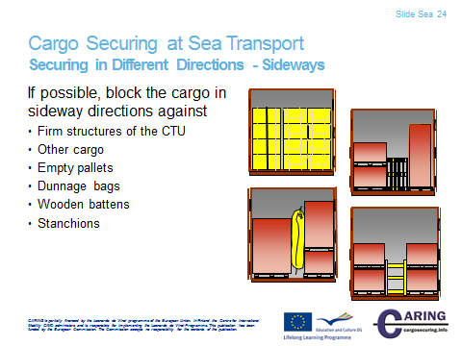

Securing in Different Directions - Sideways
The possibility to block cargo sideways is depending on the strength of the superstructure of the cargo transport unit. If the void space is too large, depending on national regulations, it can be filled out by

- Other cargo
- Empty pallets
- Dunnage bags (air bags) or other suitable means.
- Wooden battens
- Stanchions
- The cargo can alternatively also be supported by vertical bars for limited weights.

Blocking against parts of the CTU
Blocking against parts of the CTU signifies that the load is placed in close contact with the headboard, sideboards or walls. Where cargo of regular shape and size is loaded, a tight stow from wall to wall should be sought. However, in many instances some void space may occur. If the space between the packages is too large, then the stow should be secured by using empty pallets, dunnage, folded cardboard, air bags or other suitable materials. All unnecessary empty spaces must be avoided and that becomes more important with increased weight.

Blocking by timber chocking
The load must at times, due to its form or weight, be placed in a position on the platform away from the headboard, sideboard or walls. Then a construction of timber chocking and nailed battens can be used to prevent the load from sliding. For road transports the dimensions and number of the battens are to be estimated to bear the whole weight forward, half the weight backwards and to the sides.

Notes
__________________________________________________________________________________
__________________________________________________________________________________
__________________________________________________________________________________
__________________________________________________________________________________
__________________________________________________________________________________
__________________________________________________________________________________
__________________________________________________________________________________
__________________________________________________________________________________

[Slide Sea 25]

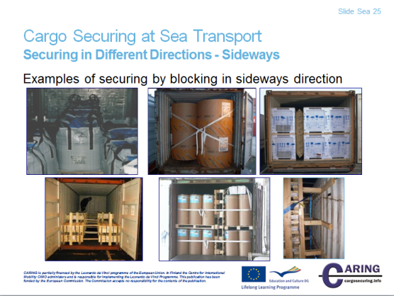

Securing in Different Directions - Sideways
Examples of securing by blocking in sideways direction
- Blocking by other cargo
- Blocking by other cargo
- Blocking by dunnage bag
- Blocking by wooden battens
- Blocking by empty pallets
- Blocking by wooden battens
Notes
__________________________________________________________________________________
__________________________________________________________________________________
__________________________________________________________________________________
__________________________________________________________________________________
__________________________________________________________________________________
__________________________________________________________________________________
__________________________________________________________________________________
__________________________________________________________________________________

[Slide Sea 26]

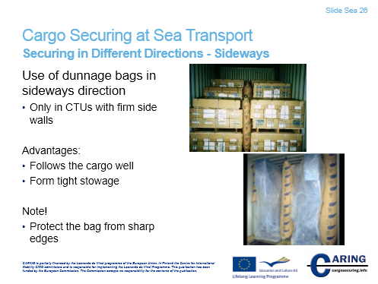

Securing in Different Directions - Sideways
Dunnage bags (air bags)
If the CTU has strong sides/walls, air bags (dunnage bags) can be used. They are very efficient but may damage the cargo, sideboards or walls if the air bags are blown up too much. The air pressure must not be more than recommended by the manufacturer.

Notes
__________________________________________________________________________________
__________________________________________________________________________________
__________________________________________________________________________________
__________________________________________________________________________________
__________________________________________________________________________________
__________________________________________________________________________________
__________________________________________________________________________________
__________________________________________________________________________________

[Slide Sea 27]

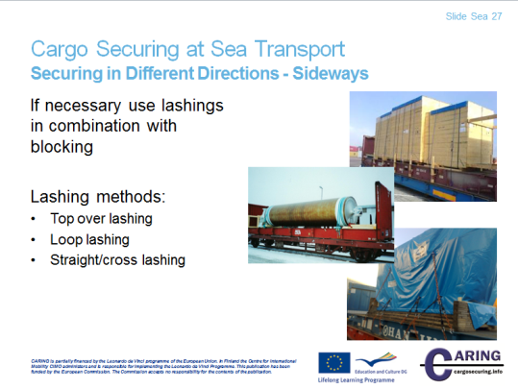

Securing in Different Directions - Sideways
If blocking cannot be sufficiently arranged, the cargo can be secured by complementary lashings or by lashings only.

Top-over lashings
The top-over lashings run from side to side over the load. The top-over lashing is most efficient if the angle between the loading platform and the upright part of the lashing is close to 90°. If this angle diminishes the lashing loses effect.
In the Quick Lashing Guides, the number of lashings is calculated for an angle between 90° and 75°. At angles between 75° and 30° the number of lashings must be doubled. If the angle is less than 30° the lashing has almost no effect and another securing method must be used.
To prevent longitudinal tipping, the lashings should be placed symmetrically.

Loop lashing
A Loop lashing is not just a single lashing. They are used in pairs to be effective – one loop around the load from each side of the platform – and they are very effective to prevent sliding and tipping. Furthermore, they must be accompanied by securing in the forward/backward directions. Each cargo section must be secured with at least two pairs of lashings in order to not twist. If the different cargo sections are supporting each other and thereby stop twisting, only one loop lashing may be needed per section of cargo.

Straight lashing – Cross lashing
This type of lashing is used primarily on larger machineries and cargoes where the lashing can be attached directly to the cargo. This lashing can prevent both sliding and tipping. Depending on the angle between the attachment point on the cargo and the attachment point on the floor, the effect to prevent tipping is different to that of sliding. If the lashings are put crossways (cross lashing) it is of utmost importance that the cross is located over the centre of gravity of the cargo - otherwise the lashings may help the cargo to tip over. In the Quick Lashing Guides, the number of lashings is calculated for horizontal and vertical angles between 30° and 60°.
Notes
__________________________________________________________________________________
__________________________________________________________________________________
__________________________________________________________________________________
__________________________________________________________________________________
__________________________________________________________________________________
__________________________________________________________________________________
__________________________________________________________________________________
__________________________________________________________________________________

[Slide Sea 28]

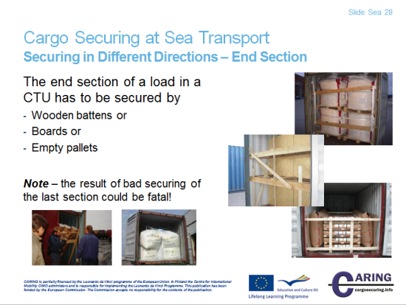

Securing in Different Directions – End Section
All personnel unloading cargo are exposed to danger if the cargo has shifted in the CTU during the transport. This is in fact the most common reason for injuries, sometimes fatal, caused by insufficient cargo securing. When loading, all packages have to be secured in such a way they don´t fall out when the doors are opened.

The end section in a container load has to be secured by
- Wooden battens or
- Boards or
- Empty pallets

Notes
__________________________________________________________________________________
__________________________________________________________________________________
__________________________________________________________________________________
__________________________________________________________________________________
__________________________________________________________________________________
__________________________________________________________________________________
__________________________________________________________________________________

[Slide Sea 29]

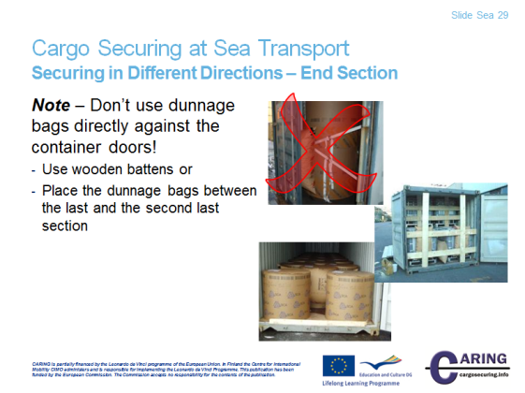

Securing in Different Directions – End Section
During the voyage the cargo can move and build up a high pressure in the dunnage bags. If the dunnage is placed against the doors of the CTU, the doors can more or less blast up in the face of the personnel opening them. Therefore:
Note – Don’t use dunnage bags directly against container doors!
Instead use wooden battens against the doors or place the dunnage bags between the last and the second last section
Notes
__________________________________________________________________________________
__________________________________________________________________________________
__________________________________________________________________________________
__________________________________________________________________________________
__________________________________________________________________________________
__________________________________________________________________________________
__________________________________________________________________________________

[Slide Sea 30]

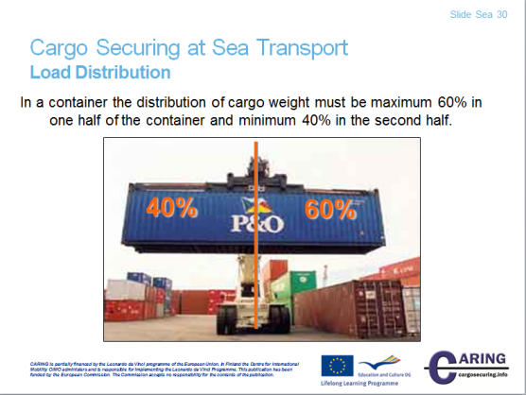

Load Distribution
There is no standard or regulation for the load distribution in a CTU (container) but a thumb rule is:
In a container the distribution of cargo weight must be maximum 60% in one half of the container and minimum 40% in the second half. This is valid both in longitudinal and transverse directions.
In a 20 foot container the centre of gravity can be off the geometrical centre by ± 30 cm and ± 60 cm in a 40 foot container. When the loader have reached the middle of the container a tip is to stop loading and sum the weight of the packages loaded. The weight shall not exceed 60 % of the total weight.
Notes
__________________________________________________________________________________
__________________________________________________________________________________
__________________________________________________________________________________
__________________________________________________________________________________
__________________________________________________________________________________
__________________________________________________________________________________
__________________________________________________________________________________

[Slide Sea 31]

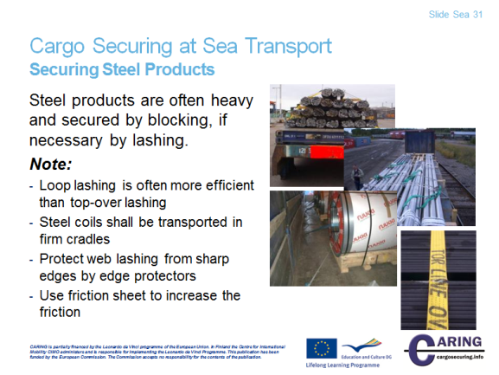

Securing Steel Products
Steel coils
Coils, steel or other metals, can be transported laying on the end or standing on the roll. Contrarily to paper reels, coils transported on the roll are called “standing” and coils transported on the ends are called “lying”. However, this may differ between steelworks depending on the widths and diameters of the produced coils.

Lying coils
The coils should be placed close together on a surface with a high coefficient of friction. Depending on the number of coils and their sizes, it may be necessary to place them in groups on the CTU to obtain good weight distribution.
The coils should be bottom blocked and secured by top-over lashings with heavy edge protectors. It may be necessary to attach spring lashings in both travelling directions.
If the cargo is placed in groups, each group should be individually secured.

Standing coils
Narrow standing coils
Due to the weight distribution, the coils are spread out on the platform. Many coils are transported completely covered with closed centre cores. To be able to secure coils with closed cores efficiently, they should be placed with the axes along the CTU.
Longitudinal dunnage at the bottom of the coils prevents sliding forwards and backwards both at braking and shunting. Long battens on top of the coils secured by loop lashings prevent tipping longitudinally.

One pair of loop lashings per coil secured to the sides of the CTU prevents the coils from sliding or rolling transversally. The loop lashings are designed for the stress that may occur during the transportation. This means that the strongest lashings are required at sea transport in area C.

Wide standing coils
Wide standing coils can be loaded and secured in the same way as narrow coils. Since wide coils are often heavy, the longitudinal distance between them can be large. To minimise the risk of cracking the blocking battens, the top as well as the bottom batten is supported to the platform floor. The horizontal battens and the supports should be nailed to the floor of the CTU. Double pairs of loop lashings may be required to secure the coils transversally.

Standing coils with open cores
Standing coils with open cores can be loaded and secured according to the same principles as for coils with closed cores.

In general, lashings applied through the centre of the coils should be performed with chain or wire. Web lashings are easily damaged by the sharp steel edges and should be avoided or carefully protected.

Rod wire
Rod wire is mostly transported in coils, packed to large units of 4-6 wire coils in each. Even if the coils may seem rigid during loading, they may act like living snakes during transport. The coils should if possible be placed in rows with the centre axis longitudinally to the load carrier. The different rows are lashed together in sections. One loop lashing is used from each side of the section, secured to the platform bed on each side and through the centre of the opposite coil.

Rod wire is often loaded by forklifts equipped with a pole. Loading to trailers is often performed from the side demanding another cargo securing method. The rod wire can be loaded in individual heaps to meet the weight distribution required in the trailer. To prevent movements forwards and backwards, battens are nailed in front of and behind each section of the rod wire. The sections are lashed together and secured to the cargo transport unit. The best way to prevent the wire coils from tipping sideways is to use centre stanchions.

The rod wire can also be spread into two rows on the platform. In this case, blocking battens are placed along the sides of the wire coils. Loop lashings are attached to either side to prevent tipping sideways. At the rear end a bar or wedge is placed.
If the weight capacity and width of the trailer admit, the number of coils can be increased to three in some of the sections. In some cases the coils are too wide to be loaded three per cross section. In this case some coils are loaded in an upper layer. These coils are carefully secured to the coils in the bottom layer. At sections with two layers, the loop lashings are attached to the coils in the upper layer as extra support.

In containers the rod wire is loaded with forklift trucks equipped with a pole. The coils can often be loaded in two rows in the container. If a 20ft container is used, the cargo often covers the container floor and the only securing required is to prevent the coils from leaning towards the doors.

A 40ft container has a larger volume/weight capacity ratio than a 20ft container. Thus void space occurs which cannot be used. An alternative loading pattern that fills the entire length of the container is a load of single and double rows.
The single loaded coils can be secured sideways by a lashing of for example heavy steel straps or wire applied through the centre hole of the coils. If a single coil is loaded in the front of the container or at the end doors, the lashing is applied around a firm bar in order to secure also the coils at the ends. The lashing also prevents the coils from leaning towards the doors.

Metal and steel bars
To secure bars they must be sorted due to length and blocked by firm H-braces both forwards and backwards. Loop lashings can be used to reduce the pressure from the cylindrical bars onto the sideboards. If square-shaped slabs are transported with cylindrical bars the best placement for the square-shaped bars is close to the sideboards.

Steel sheets
Steel sheets are a large transport commodity and demands quite a lot of cargo securing since the friction is rather low and the weight is considerable.

To make sure that the steel sheets can stand the longitudinal forces which may occur at braking and shunting accelerations, stable blocking like H-braces or spring lashings of wire or chain backwards and forwards are needed.

The sideways blocking is done by wire or chain loop lashings. If the plates are wider than the CTU, straight ( cross ) lashings may be used. If only top-over lashings are used, the number of lashings must be increased.

At sea transport of heavy steel sheets strong wire or chain lashings alternatively stanchions are required to prevent cargo sliding sideways.
Quite a lot of special steel sheets are transported in racks and boxes. For these transports friction sheets combined with loop lashings can be used with a good result for securing against transverse forces. The longitudinal forces at shunting and braking are absorbed by braces.

Notes
__________________________________________________________________________________
__________________________________________________________________________________
__________________________________________________________________________________
__________________________________________________________________________________
__________________________________________________________________________________
__________________________________________________________________________________
__________________________________________________________________________________
__________________________________________________________________________________

[Slide Sea 32]

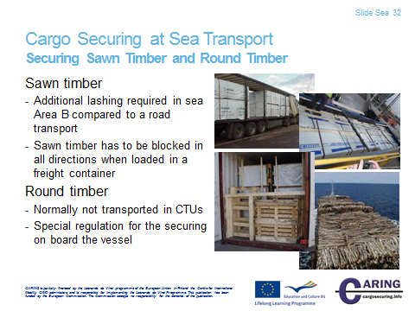

Securing Sawn Timber and Round Timber
Sawn and planed wood
Today wood is mainly transported in packages. There are packages of descending lengths and boards cut to a standardised length. If packages of both kinds are to be loaded on the same CTU, the packages of the same length should normally be loaded at the bottom to obtain a compact and stable first layer and to keep the centre of gravity as low as possible. The cargo should be secured by centre stanchions and top-over lashings. Also in the longitudinal direction the cargo must be secured, mainly by blocking against the headboard. Stable packages can be secured without centre stanchions or by long heavy pieces of dunnage between the layers.

Round timber
Transporting round timber
- Place the load, whenever possible, against the headboard or similar restrains
- The load is transversely supported by stanchions with at least the same height as the load
- Use chain or web lashings with toggle or load binder
- Timber stacked transversely is not recommended. It is safer to transport longitudinally
- Check the load and lashing before passing from forest road to public road
- Recheck the load and lashing regularly during the transport

Round timber stacked longitudinally
- Each log shall be restrained by at least two stanchions
- Shorter timber should be placed in the center of the load
- The top of the load not higher than the stanchions
- The top middle must be higher than the side timber
- Each cargo section consisting of timber with bark under 3.3 m should be lashed with at least 1 top-over lashing
- Each cargo section over 3.3 m and sections consisting of timber with removed bark should be lashed with at least 2 top-over lashings.

Notes

__________________________________________________________________________________

__________________________________________________________________________________

__________________________________________________________________________________

__________________________________________________________________________________

__________________________________________________________________________________

__________________________________________________________________________________

__________________________________________________________________________________

__________________________________________________________________________________

[Slide Sea 33]

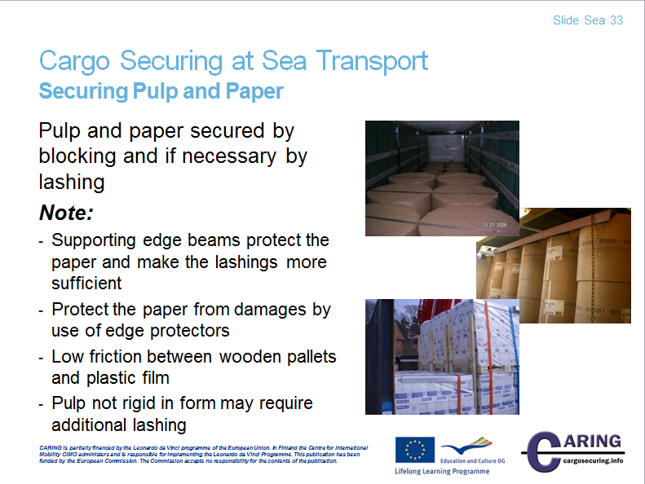

Cargo Securing at Sea Transport
Securing Pulp and Paper
Paper products make a considerable share of transports. They are often transported in sea or railway systems organised by the different forest industries. But due to various circumstances a lot of paper products are also transported on cargo transport units outside the pure paper transport systems.

Paper reel
Usually for paper reel transports, the following parameters are of interest:
Weight: normally not exceeding 5 ton
Diameter: normally not exceeding 2 m
Width: varies in wide range up to 4,5 m

Paper reels can be transported laying on the reel or standing vertically on the end. The standing reels are not so much exposed to risks than laying reels. Because of the lack of equipment for handling standing reels some customers specify a transport of laying reels. Specifically, broad reels are transported in the laying position.
Note!
When transporting standing reels in a container, the reels that are beside the side walls are specifically exposed to damages, because the bottom edge of the wall has small protrusion, which can cause damages, though the small void space between reels and wall is filled with carton.

Sheet-paper on pallet
Sheet-paper are stowed on pallets to facilitate the paper handling. The sheet-papers are normally lashed to the pallet by shrink film and lashings. The pallets may be equipped with lids, protecting the sheet-paper on top when the pallets are stacked.
Sheet-papers are tailor-made in accordance with the customer’s order and there are an enormous amount of dimensions. Therefore the pallets are normally tailor-made by the same dimensions as the sheets. Some paper mills, however, try to use standardised pallets of slightly larger dimensions than the sheet-papers. Loading of pallets of larger dimensions than the sheet-papers causes voids in the stow, which is a source of transport damages.

General guidelines for the packing and securing of paper products
Paper products and especially paper reels are large transport commodities. Handling and transport of large and regular shipments are routine procedures.
When small quantities of paper products are transported there are often difficulties in the securing of the cargo, especially when more than one mode of transport is used in combination, e.g. road/sea.
The basic rules for loading and securing of cargo are also valid for paper products. Since most of these rules are important and applicable to every transport of cargo transport units, it is important to check the cargo planning against these rules.

By the built-in blocking system of the CTU, such as corner posts and walls in containers, headboard, sideboards and edges on trailers and flats, standing paper reels in one layer can be secured by dense stowing, in some cases completed with top-over lashings. Often Quick lashing guides are used to calculate the number of top-over lashings based on actual coefficient of friction, which is capable to meet the acting forces.

In cargo transport units without built-in blocking equipment, the paper reels must be secured in some other way. Different methods can be used solely or in combination.
Bottom blocking can be performed against sideboards or stanchions, but layer blocking is more difficult to arrange without damaging the paper. Instead it’s recommended to the friction to have well tensioned top-over lashings placed over edge supporting beams.
By lashing a number of reels together by round-turn lashings, the height/width ratio can be lowered and thereby the risk of tipping. If the reels are high and narrow, horizontal round-turn lashings can be used. When loading paper reels in containers, they can be blocked and then there is no risk of tipping. But loading paper reels on flat racks or on roll trailers and other CTU with any means for sideways blocking, round-turn lashing can be used to minimize the risk of tipping.

Securing of paper reels standing on the end in one and a half layer in soft-walled CTU:s
Most paper qualities and paper reel dimensions must be stowed in one and a half layer in a cargo transport unit to make use of the full payload of the CTU.
The paper reels in the second layer are prevented from moving forwards or backwards by raised units, in front of and behind the reels in the second layer. To prevent the paper reels in the second layer from tipping forwards or backwards, spring lashings or horizontal round-turn lashings are attached.

Because of the large bursting effect that may occur, careful designing of the cargo securing arrangement must be performed at all kinds of zigzag stowage. To prevent paper reels in the second zigzag stowed layer from moving sideways at hard braking or shunting, at least one round-turn lashing per three cargo sections is required.

Packing and securing of standing paper reels in one and a half layer in strong-walled CTU:s
Also in strong-walled cargo transport units like containers, the paper reels must as a rule be loaded in one and a half layer to make full use of the payload of the container. Paper reels, with a wider diameter than half the breadth of the CTU, can only be loaded in one row while more narrow reels can be loaded in several rows.
Because of the weight distribution the second layer must be located so, that it do not disturb the weight distribution of the unit. The second layer can be blocked by thresholds made by high paper reels in the bottom layer. If all reels are of the same height, the reels in front of and behind the top layer are raised by pallets or dunnage. The bottom layer is loaded tight to the front end wall of the unit while free space at the doors is blocked with filling material.

In front of and behind the top layer high paper reels are placed. If all reels are of the same height, the reels in front of and behind the top layer are raised by pallets or dunnage. To prevent the paper reels in the top layer and the rear reels in the bottom layer from tipping forwards or backwards, round-turn lashings may be used.

Packing and securing of standing paper reels with a large diameter in one or more layers in strong-walled CTU:s
When the paper reels have a diameter wider than half the CTU breadth they can only be loaded in one row. To utilise the maximum CTU length and at the same time support the paper reels on at least three places on the reel, they can be densely loaded in a zigzag pattern from the front end wall of the CTU. The rear reels are secured by a dunnage bag between the two last reels and filling material from the last reel to the rear wall. In a container blocking is to be made against the left door. Note, never use air bags directly against the doors.
Because of the weight distribution a second layer must be located so, that it does not disturb the load distribution of the unit. In front of and behind the top layer high paper reels are placed. If all reels are of the same height, the reels in front of and behind the top layer are raised by pallets or dunnage.

Packing and securing of lying reels in one and a half layer in soft-walled CTU:s
If, depending on demands from the customer, the paper reels must be transported laying on the roll, they should be loaded with their axles across the CTU. To make use of the full payload, also the lying reels must usually be loaded in more than one layer.
The bottom layer is placed tight to the headboard and each paper reel is secured by small chocks to make the handling of each reel easier. The reels at the end of the cargo transport unit must be secured against backward movements by properly fixed chocks of a height of half the reel radius. For railway transports, the height of the chocks must be at least 20 cm for reels with a diameter over 80 cm.

The paper reels in the top layer should be secured against forward movement in the CTU by securing of the first reel in each row to the reels in the lower layer by vertical round-turn lashings. The securing to prevent the reels from tipping or the reels in the second layer from sliding should be designed according to the basic cargo securing.

Packing and securing of laying reels in one and a half layer in strong-walled CTU:s
When loading laying reels in strong-walled units, the walls are used for securing. The reels are placed along the sides and possible void is left in the middle. The void is filled by e.g. air dunnage bags. Also empty pallets or blocking braces can be used. The reels are secured longitudinally in the same way as in soft-walled units.

Packing and securing of sheet-paper on pallets in one and a half layer in soft-walled CTU:s
To lower the risk of tipping sideways, the paper sheet pallets are preferably loaded by their widest sides across the cargo transport unit. If the CTU would be filled to the weight limit by sheet-paper, it is necessary for most of the pallet dimensions to put a certain number of pallets in a second layer.
The pallets in the bottom layer are placed dense to the headboard to prevent the first layer from moving forward. Movement backwards is prevented by filling possible void between pallets and rear board for example by empty pallets.

If the pallets are not densely stowed between the sideboards they must be prevented from sliding and tipping sideways by blocking and/or lashing according to the basic cargo securing principles.
If the weight distribution in the CTU permits, also the pallets in the second layer should be placed dense to the headboard. If they must be placed in the middle of the CTU, they can be prevented from moving forwards by a spring lashing. To protect the cargo, a spring lashing placed over a pallet should be used. As an alternative to spring lashing, a solid board can be placed between pallets in the lower layer. The board must be high enough to give a sufficient support to the pallets in the top layer. If the CTU is to be transported by rail, there is also a need of heavy blocking preventing the top layer from moving backwards. The pallets in the top layer are prevented from moving sideways according to the basic cargo securing principles.

Packing and securing of sheet-paper on pallets in one and a half layer in strong-walled CTU:s
As for paper reels the strong walls are used for securing the cargo from moving sideways. The pallets are densely stowed against the walls and possible void is left in the middle of the unit. If the pallets are not square, the void must be placed on the right and on the left side to locate the centre of gravity transversally in the centre of the unit. The empty space should be blocked by air dunnage bags, empty pallets or braces. If air dunnage bags are used fibreboard may be necessary as protection against sharp edges.

The bottom layer should be densely stowed against the front wall and possible voids at the doors should be blocked. The pallets in the top layer can be protected from moving forwards and backwards by solid boards and vertical round-turn lashings. For rail transport, blocking is necessary in both travelling directions.

Notes
__________________________________________________________________________________
__________________________________________________________________________________
__________________________________________________________________________________
__________________________________________________________________________________
__________________________________________________________________________________
__________________________________________________________________________________
__________________________________________________________________________________
__________________________________________________________________________________

Abbreviations
CCS-code Code of Safe Practice for Cargo Stowage and Securing
CMR Convention relative au contrat de transport international de Marchandises par Route
CPC Container/vehicle Packing Certificate
CTU Cargo Transport Unit
DG Dangerous Goods
ILO International Labour Organization
IMDG International Maritime Dangerous Goods Code
IMO International Maritime Organization
ISO International Standard Organization
MEPC Marine Environment Protection Committee
MGW Maximum Gross Weight
MSC Maritime Safety Committee
UN ECE United Nation Economic Commission for Europe
SOLAS International Convention for the Safety of Life at Sea

Reference Literature
Standard: EN 12195-1:2010
European Best Practice Guidelines – Cargo Securing for Road Transport
IMO/ILO/UN ECE Guidelines for packing of cargo transport units

