Kolb's experiential learning theory (learning styles) model

Kolb's learning theory sets out four distinct learning styles (or preferences), which are based on a four-stage learning cycle (which might also be interpreted as a 'training cycle'). In this respect Kolb's model is particularly elegant, since it offers both a way to understand individual people's different learning styles, and also an explanation of a cycle of experiential learning that applies to us all.
Kolb includes this 'cycle of learning' as a central principle his experiential learning theory, typically expressed as four-stage cycle of learning, in which 'immediate or concrete experiences' provide a basis for 'observations and reflections'. These 'observations and reflections' are assimilated and distilled into 'abstract concepts' producing new implications for action which can be 'actively tested' in turn creating new experiences.
Kolb says that ideally (and by inference not always) this process represents a learning cycle or spiral where the learner 'touches all the bases', i.e., a cycle of experiencing, reflecting, thinking, and acting. Immediate or concrete experiences lead to observations and reflections. These reflections are then assimilated (absorbed and translated) into abstract concepts with implications for action, which the person can actively test and experiment with, which in turn enable the creation of new experiences.
Kolb's model therefore works on two levels - a four-stage cycle:
- Concrete Experience - (CE)
- Reflective Observation - (RO)
- Abstract Conceptualization - (AC)
- Active Experimentation - (AE)
And a four-type definition of learning styles, (each representing the combination of two preferred styles, rather like a two-by-two matrix of the four-stage cycle styles, as illustrated below), for which Kolb used the terms:
- Diverging (CE/RO)
- Assimilating (AC/RO)
- Converging (AC/AE)
- Accommodating (CE/AE)

Diagram of Kolb's learning styles
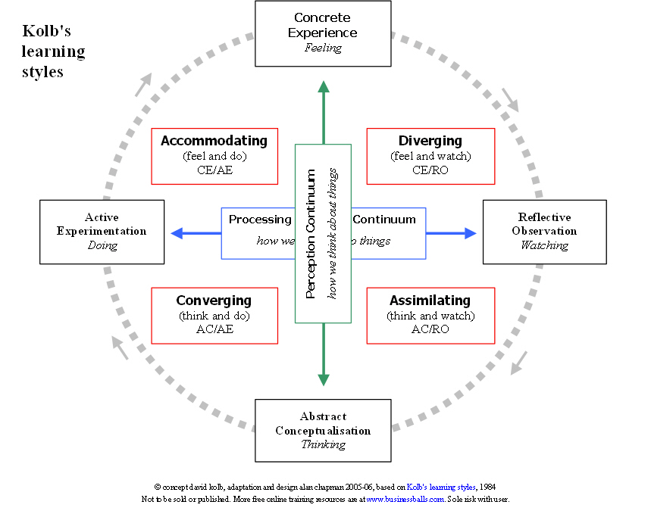

Learning styles
Kolb explains that different people naturally prefer a certain single different learning style. Various factors influence a person's preferred style: notably in his experiential learning theory model (ELT) Kolb defined three stages of a person's development, and suggests that our propensity to reconcile and successfully integrate the four different learning styles improves as we mature through our development stages. The development stages that Kolb identified are:
- Acquisition - birth to adolescence - development of basic abilities and 'cognitive structures'
- Specialization - schooling, early work and personal experiences of adulthood - the development of a particular 'specialized learning style' shaped by 'social, educational, and organizational socialization'
- Integration - mid-career through to later life - expression of non-dominant learning style in work and personal life.
Whatever influences the choice of style, the learning style preference itself is actually the product of two pairs of variables, or two separate 'choices' that we make, which Kolb presented as lines of axis, each with 'conflicting' modes at either end:
Concrete Experience - CE (feeling) -----V-----Abstract Conceptualization - AC (thinking)
Active Experimentation - AE (doing)-----V----- Reflective Observation - RO (watching)
A typical presentation of Kolb's two continuums is that the east-west axis is called the Processing Continuum (how we approach a task), and the north-south axis is called the Perception Continuum (our emotional response, or how we think or feel about it).
These learning styles are the combination of two lines of axis (continuums) each formed between what Kolb calls 'dialectically related modes' of 'grasping experience' (doing or watching), and 'transforming experience' (feeling or thinking):

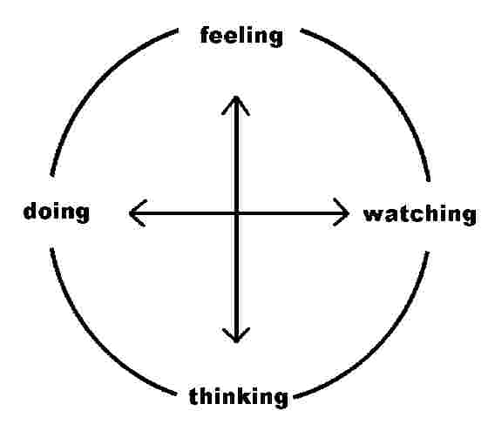

The word 'dialectically' is not widely understood, and yet carries an essential meaning, namely 'conflicting' (its ancient Greek root means 'debate' - and I thank P Stern for helping clarify this precise meaning). Kolb meant by this that we cannot do both at the same time, and to an extent our urge to want to do both creates conflict, which we resolve through choice when confronted with a new learning situation. We internally decide whether we wish to do or watch, and at the same time we decide whether to think or feel.
The result of these two decisions produces (and helps to form throughout our lives) the preferred learning style, hence the two-by-two matrix below. We choose a way of 'grasping the experience', which defines our approach to it, and we choose a way to 'transform the experience' into something meaningful and usable, which defines our emotional response to the experience. Our learning style is a product of these two choice decisions:
- how to approach a task - i.e., 'grasping experience' - preferring to (a) watch or (b) do , and
- our emotional response to the experience - i.e., 'transforming experience' - preferring to (a) think or (b) feel.
In other words we choose our approach to the task or experience ('grasping the experience') by opting for 1(a) or 1(b):
- 1(a) - though watching others involved in the experience and reflecting on what happens ('reflective observation' - 'watching') or
- 1(b) - through 'jumping straight in' and just doing it ('active experimentation' - 'doing')
And at the same time we choose how to emotionally transform the experience into something meaningful and useful by opting for 2(a) or 2(b):
- 2(a) - through gaining new information by thinking, analyzing, or planning ('abstract conceptualization' - 'thinking') or
- 2(b) - through experiencing the 'concrete, tangible, felt qualities of the world' ('concrete experience' - 'feeling')
The combination of these two choices produces a preferred learning style. See the matrix below.

Kolb's learning styles - matrix view
It's often easier to see the construction of Kolb's learning styles in terms of a two-by-two matrix. The diagram also highlights Kolb's terminology for the four learning styles; diverging, assimilating, and converging, accommodating:

 | Doing (Active  Experimentation - AE) | Watching  (Reflective Observation - RO)
Feeling (Concrete Experience - CE) | Accommodating (CE/AE) | Diverging (CE/RO)
Thinking (Abstract Conceptualization – AC) | Converging (AC/AE) | Assimilating (AC/RO)

Thus, for example, a person with a dominant learning style of 'doing' rather than 'watching' the task, and 'feeling' rather than 'thinking' about the experience, will have a learning style which combines and represents those processes, namely an 'Accommodating' learning style, in Kolb's terminology.

Kolb learning styles definitions and descriptions
Knowing a person's (and your own) learning style enables learning to be orientated according to the preferred method. That said, everyone responds to and needs the stimulus of all types of learning styles to one extent or another - it's a matter of using emphasis that fits best with the given situation and a person's learning style preferences.
Here are brief descriptions of the four Kolb learning styles:
- Diverging (feeling and watching - CE/RO) - These people are able to look at things from different perspectives. They are sensitive. They prefer to watch rather than do, tending to gather information and use imagination to solve problems. They are best at viewing concrete situations several different viewpoints. Kolb called this style 'Diverging' because these people perform better in situations that require ideas-generation, for example, brainstorming. People with a Diverging learning style have broad cultural interests and like to gather information. They are interested in people, tend to be imaginative and emotional, and tend to be strong in the arts. People with the Diverging style prefer to work in groups, to listen with an open mind and to receive personal feedback.
- Assimilating (watching and thinking - AC/RO) - The Assimilating learning preference is for a concise, logical approach. Ideas and concepts are more important than people. These people require good clear explanation rather than practical opportunity. They excel at understanding wide-ranging information and organising it a clear logical format. People with an Assimilating learning style are less focused on people and more interested in ideas and abstract concepts. People with this style are more attracted to logically sound theories than approaches based on practical value. This learning style is important for effectiveness in information and science careers. In formal learning situations, people with this style prefer readings, lectures, exploring analytical models, and having time to think things through.
- Converging (doing and thinking - AC/AE) - People with a Converging learning style can solve problems and will use their learning to find solutions to practical issues. They prefer technical tasks, and are less concerned with people and interpersonal aspects. People with a Converging learning style are best at finding practical uses for ideas and theories. They can solve problems and make decisions by finding solutions to questions and problems. People with a Converging learning style are more attracted to technical tasks and problems than social or interpersonal issues. A Converging learning style enables specialist and technology abilities. People with a Converging style like to experiment with new ideas, to simulate, and to work with practical applications.
- Accommodating (doing and feeling - CE/AE) - The Accommodating learning style is 'hands-on', and relies on intuition rather than logic. These people use other people's analysis, and prefer to take a practical, experiential approach. They are attracted to new challenges and experiences, and to carrying out plans. They commonly act on 'gut' instinct rather than logical analysis. People with an Accommodating learning style will tend to rely on others for information than carry out their own analysis. This learning style is prevalent and useful in roles requiring action and initiative. People with an Accommodating learning style prefer to work in teams to complete tasks. They set targets and actively work in the field trying different ways to achieve an objective.

Final remarks
As with any behavioural model, this is a guide not a strict set of rules. Nevertheless most people clearly exhibit clear strong preferences for a given learning style. The ability to use or 'switch between' different styles is not one that we should assume comes easily or naturally to many people.
Simply, people who have a clear learning style preference, for whatever reason, will tend to learn more effectively if learning is orientated according to their preference. For instance - people who prefer the 'Assimilating' learning style will not be comfortable being thrown in at the deep end without notes and instructions. People who like prefer to use an 'Accommodating' learning style are likely to become frustrated if they are forced to read lots of instructions and rules, and are unable to get hands on experience as soon as possible.

Source: http://www.businessballs.com/kolblearningstyles.htm

Other learning style test:
http://www.engr.ncsu.edu/learningstyles/ilsweb.html

Further reading:
See article Kolb (2005): www.learningfromexperience.com/images/uploads/Learning-styles-and-learning-spaces.pdf

Kolb Test
Knowing a person's (and your own) learning style enables learning to be orientated according to the preferred method. That said, everyone responds to and needs the stimulus of all types of learning styles to one extent or another - it's a matter of using emphasis that fits best with the given situation and a person's learning style preferences.

The test

Step 1
In total the test consists of nine questions, each with four answers. For every question you have to prioritise the answers. The answer that applies to you the most has to be valued with four points, the answer that applies to you second has to be valued with three points, the third with two points and the answer that applies less to you with one point. Make sure you value every answer. Maybe all answers are equally applicable to you, maybe none of the answers apply to you, still you have to value every answer differently.

The Nine Questions
1. You want to learn how to sail. In what way will you do this?
A- I directly get into a boat, and try to sail
B- I stay ashore, and observe how others are doing it.
C- I first consult literature on how to sail
D- I ask someone to do it for me and imitate this

2. You get a new phone. You want to use it directly. In what way will you do this?
A- I first think about all the things I can do with it
B- I first inquire what its functions are and what you can do with them
C- I first read the instructions very carefully
D- I immediately try everything

3. During technical skills class you have to do a project. What do you do?
A- I first think about what the goal is and how to achieve this
B- I first read the assignment completely and look at the drawing
C- I first look at the application of the project
D- I start to work at it immediately

4. On the radio you listen to an exciting story. Later on you want to repeat it. What do you do?
A- I pretend as if the story is happening at this moment and that I am part of it
B- I like the story very much and want to do it by myself
C- I first want to know if the story is right
D- I just repeat the story

5. You have some free days. You can choose between two options, visit your family or enjoy some time with your friends. What do you do?
A- I try to imagine what the possibilities for both options are. I find it difficult to make a choice
B- I do not think about it for a long time. “You just have to make the best of it”
C- I try to get to know as much as possible about both options. After that, I will make a decision
D- I consider what I find most useful for this moment. I can make choices very easily

6. You want to buy a new bicycle. What do you do?
A- I think about places I can go with my bicycle and how much fun I will have
B- I want to know exactly what’s on the bicycle, which one is the best and how much it costs.
C- I want to try it directly
D- I look at which bicycle is most suitable

7. You will get a test on engine management. How will you prepare?
A- I learn everything I have to know for the exam
B- I try to understand everything about engine management
C- I write down the most important things
D- I study because I have to

8. You are about to accept a new job. How do you make a decision?
A- I try to imagine how it will be for me to do the job
B- I first want to know exactly how hard I need to work and what I will earn
C- I want to know exactly what one needs to do in this company and how the company is working
D- I will start working and will notice automatically if I like it

9. You can choose how to be taught in a foreign language. How do you want?
A- I would like the teacher to tell stories
B- I would like to do projects
C- I would like to have clear assignments
D- I would like to know what the purposes of the assignments are

Step 2
How to continue:
You gave the answers 4, 3, 2 or 1 point.
You now have to sum up the points that you gave to answers A for six of the nine questions, as indicated in the table below (For Answer A you sum up the points of Questions 2, 3, 4, 5, 7 and 8).
Then you have to repeat this for answers B, C and D.
Attention! Not all the questions are part of it!

Answer A : Question (2).... + (3)…. + (4).... + (5).... + (7).... + (8).... = …. points = CE
Answer B : Question (1).... + (3)…. + (6).... + (7)…. + (8)…. + (9).... = …. points = RO
Answer C : Question (2).... + (3).... + (4).... + (5).... + (8).... + (9).... = …. points = AC
Answer D : Question (1).... + (3).... + (6).... + (7).... + (8).... + (9).... = …. points = AE

Fill in the drawing (figure 1):
On the CE axis, fill in the final score of Answer A,
On the RO axis, fill in the final score of Answer B,
On the AC axis, fill in the final score of Answer C and
On the AE axis, fill in the final score of Answer D

Now you can see the amount you use of each learning style.

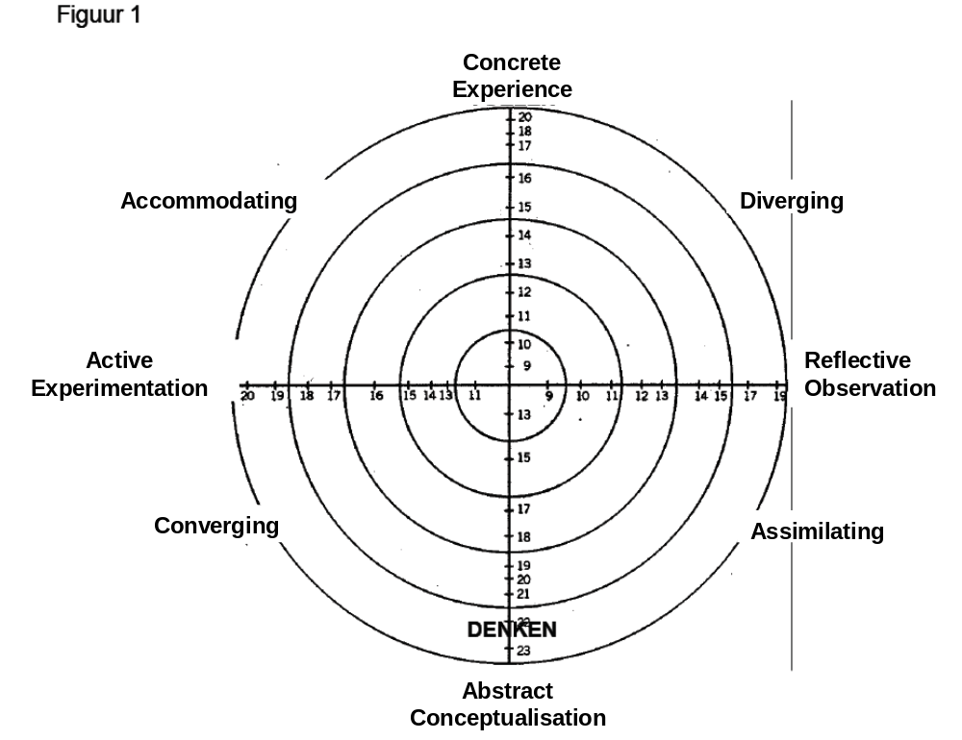
22

Which learning style applies to you?
In order to find out which learning style applies to you, you have to complete figure 2 (next page); how to do this: Look at the number of points you have at the CE score, the RO score, the AC score and the AE score. My scores are:

CE ________

RO ________

AC ________

AE ________

Fill in the points and do the calculation. It is possible to have a negative score, e.g. -5.
AC score ... minus / – CE score .... =
AE score .... minus / – RO score .... =

Indicate the AC/CE score on the vertical axis. Indicate the AE/RO score on the horizontal axis. Draw a line between the two numbers that you have indicated. You now can see what learning style you have.
Figure 2
