Title of the Paper
First Author¹[0000-1111-2222-3333] and Second Author²[1111-2222-3333-4444]
¹ Affiliation, Town/City, Country
² Affiliation, Town/City, Country
correspondingauthor@email.com
Abstract. The abstract should summarize the contents of the paper in up to 250 words.
Keywords: List of 3 to 6 keywords separated with commas
- Introduction (Heading 1)
This template includes author instructions for the Ethicomp 2022 which should be followed with full paper. The final paper should include the names of all authors (first name(s) surname(s)), their ORCIDs (if possible) and affiliations. Also at least one e-mail should be provided. Please, use the provided styles of this template to help editors of the proceedings.
- A Section: Structure
  - A Subsection
The first paragraph a section or a subsections are not intended (style: Normal first).
Subsequent paragraphs are indented (style: Normal).

Third level heading (Style: Heading3)
Third level headings are not numbered.

Fourth level heading (Style: Heading4)
The paper should contain no more than four levels of headings.
Heading levels are listed in the Table 1.

Table 1. Table captions are placed above the table. (Use Caption style.)
Heading level | Example | Font size and style
Title (centered) | Title Of the Paper | 14 pt, bold
1st level (Heading 1) | 1 Introduction | 12 pt, bold
2nd level (Heading2) | 2.1 Subsection | 10 pt, bold
3rd level (Heading3) | Run-in Heading | 10 pt, bold
4th level (Heading4) | Lowest Level Heading | 10 pt, italic
If you use long quotations, format them with Quote-style (indented, italic) as follows:
“Lorem ipsum dolor sit amet, consectetur adipiscing elit. Sed sagittis eget ipsum rhoncus convallis. Vivamus rhoncus sit amet diam mattis fermentum. Donec ut euismod nulla, et volutpat enim. Nullam a lacus egestas, maximus felis quis, bibendum tortor.”(Author, year, p.)
If you have a need to use equations they are centered (style: Equation):
x + y = z

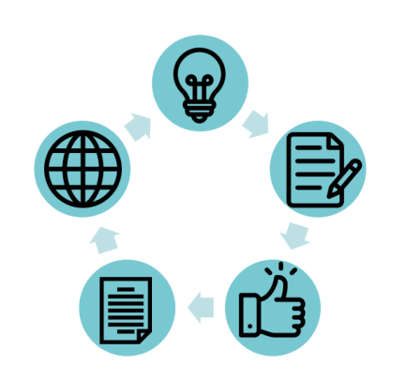
Images, illustrations and charts are recommended when handling data or complex issues (see Fig. 1.).
Fig. 1. A figure caption is placed below the figure. Remember to cite the original source if the figure is not yours. (Use Caption style)
- Citations and references
In citations and references should be made in APA style, i.e. by citing in text name or names of the author(s) and the year of the publications separated with comma. Complete guide for APA style can be found from: https://apastyle.apa.org/
For examples on different referencing styles see https://apastyle.apa.org/style-grammar-guidelines/references/examples
Reference list (style: Reference item) is ordered in the alphabetical order based on the author name.

References
Author, A. (Publication Year). Article title. Periodical Title, Volume(Issue), pp–pp. https://doi.org/zz.zzzz/aaaxxxxxxx
Author, B. (Publication Year). Title of the book. Publisher City, State: Publisher. https://doi.org/zz.zzzz/aaaxxxxxxx
Author, C. (Year, Month/Date of Publication). Article title. Retrieved from URL

